International Curling Tournament

VENTSPILS CUP 2017
24 - 26 August

APPLICATION FORM

1. | Title of the team:
2. | Curling Club:
3. | Participants:
 | 1st
 |  | name, surname, e-mail
 | 2nd
 |  | name, surname, e-mail
 | 3rd
 |  | name, surname, e-mail
 | 4th
 |  | name, surname, e-mail
 | Alternate
 |  | name, surname, e-mail
4. | Skip of the team:
 |  | name, surname
5. | Country:
6. | Address:
7. | Phone number:
8. | E-mail:
9. | Contact person:

Dear participant,
Please send this application form to us until 10 August 2017 by e-mail: dace.abelite@gmail.com

Thank You!

We will kindly assist in booking a hotel for you. Please fill in the 2nd page.

Hotel „Venta”
Jūras street 14, Ventspils
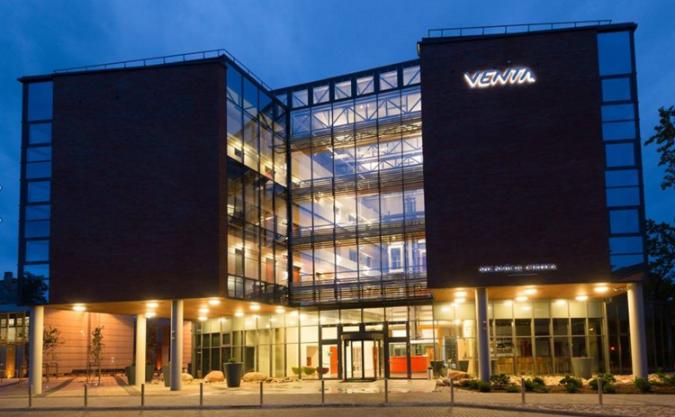
The distance from ice hall ~ 900m

Room type:
Twin room: 3536 EUR

Breakfast is for additional price.
Breakfast for one person: 5,00 EUR.

Room type: | Check in date: | Check out date: | Number of rooms:

- - - - - - - - - - - - - - - - - - - - - - - - - - - - - - - - - - - - - - OR - - - - - - - - - - - - - - - - - - - - - - - - - - - - - - - - - - -

Hotel of the Olympic Centre “Ventspils”
Lielais prospekts 33, Ventspils
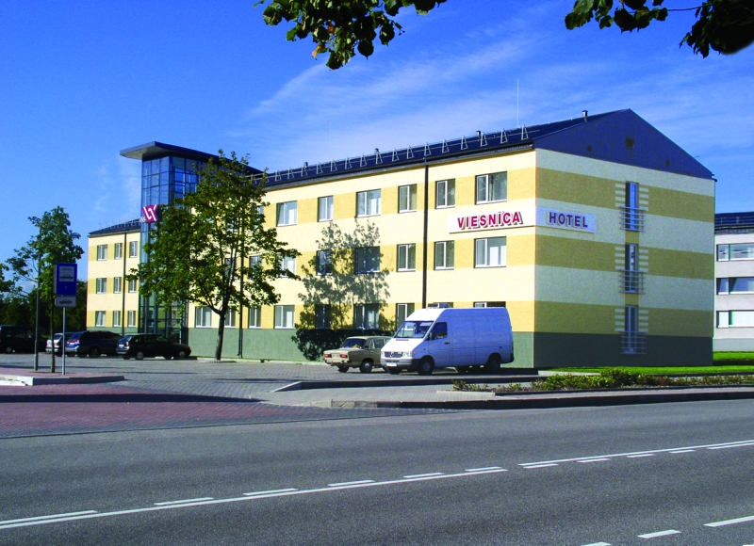
www.hotelocventspils.lv

The distance from ice hall ~ 200m
Room type:
Twin room: 38 EUR
Triple room: 48 EUR
Triple + additional bed: 58 EUR

Breakfast is for additional price.
Breakfast for one person: 4,50 EUR.

Room type: | Check in date: | Check out date: | Number of rooms:

