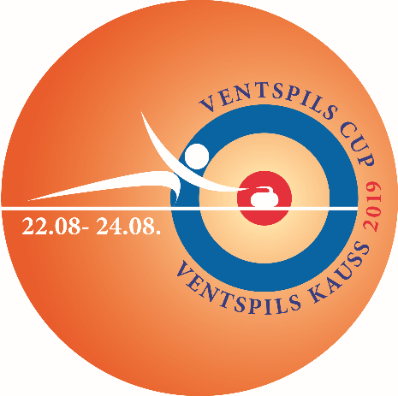

International Curling Tournament

VENTSPILS CUP 2019
22 - 24 August

APPLICATION FORM

1. | Title of the team:
2. | Curling Club:
3. | Participants:
 | 1st
 |  | name, surname, e-mail
 | 2nd
 |  | name, surname, e-mail
 | 3rd
 |  | name, surname, e-mail
 | 4th
 |  | name, surname, e-mail
 | Alternate
 |  | name, surname, e-mail
4. | Skip of the team:
 |  | name, surname
5. | Country:
6. | Address:
7. | Phone number:
8. | E-mail:
9. | Contact person:

Dear participant,
Please send this application form to us until 5 August 2019 by e-mail: dace.abelite@gmail.com

Thank You!

We will kindly assist in booking a hotel for you. Please fill in the 2nd page.

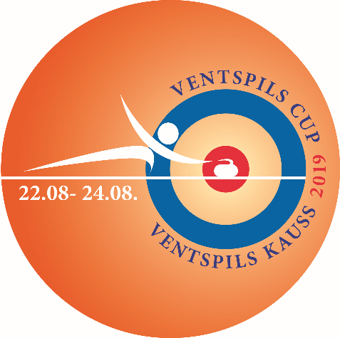

Hotel of the Olympic Centre “Ventspils”
Lielais prospekts 33, Ventspils, Latvia
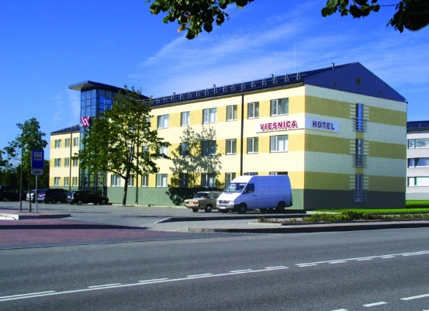
www.hotelocventspils.lv

The distance from ice hall ~ 200m
Special price for participants of Ventspils Cup
Room type:
Twin room: 24 EUR
Triple room: 36 EUR
Triple + additional bed: 46 EUR

Breakfast is for additional price.
Breakfast for one person: 4,50 EUR.

Room type: | Check in date: | Check out date: | Count of rooms:

